Semester Project Report


Automatic Car Parking System

Group Members:
- Rida Fatima (FA24-BCE-098)
- Javeria Awais (FA24-BCE-088)
- Zainab Fahim (FA24-BCE-076)

Course Name: (CSC101) Programming Fundamentals.
Instructor: Ms. Tabassum Nawaz.

Introduction:
The Automatic Car Parking System developed using C++ aims to tackle the increasing challenges of parking management in densely populated urban areas. As cities grow and vehicle numbers rise, locating a vacant parking spot has become a time-consuming and frustrating task for drivers. This results in unnecessary traffic congestion and elevated emissions. Leveraging C++ for its efficiency and system-level capabilities, this project seeks to automate the parking process, minimize human intervention, and optimize the use of parking space resources.

Problem Statements:
- Inefficient management of parking spaces in urban environments contributes to heavy traffic congestion and driver dissatisfaction.
- Traditional parking systems rely heavily on manual operation, leading to frequent human errors, slower processing times, and higher staffing requirements.

Objectives:
- To design and implement a C++-based automated system that intelligently directs vehicles to available parking spots.
- To significantly reduce the time and effort drivers spend locating parking spaces.
- To effectively integrate hardware components (e.g., sensors, microcontrollers) with software modules written in C++ for real-time, reliable parking space monitoring and allocation.

Fig .01: Car parking system working.

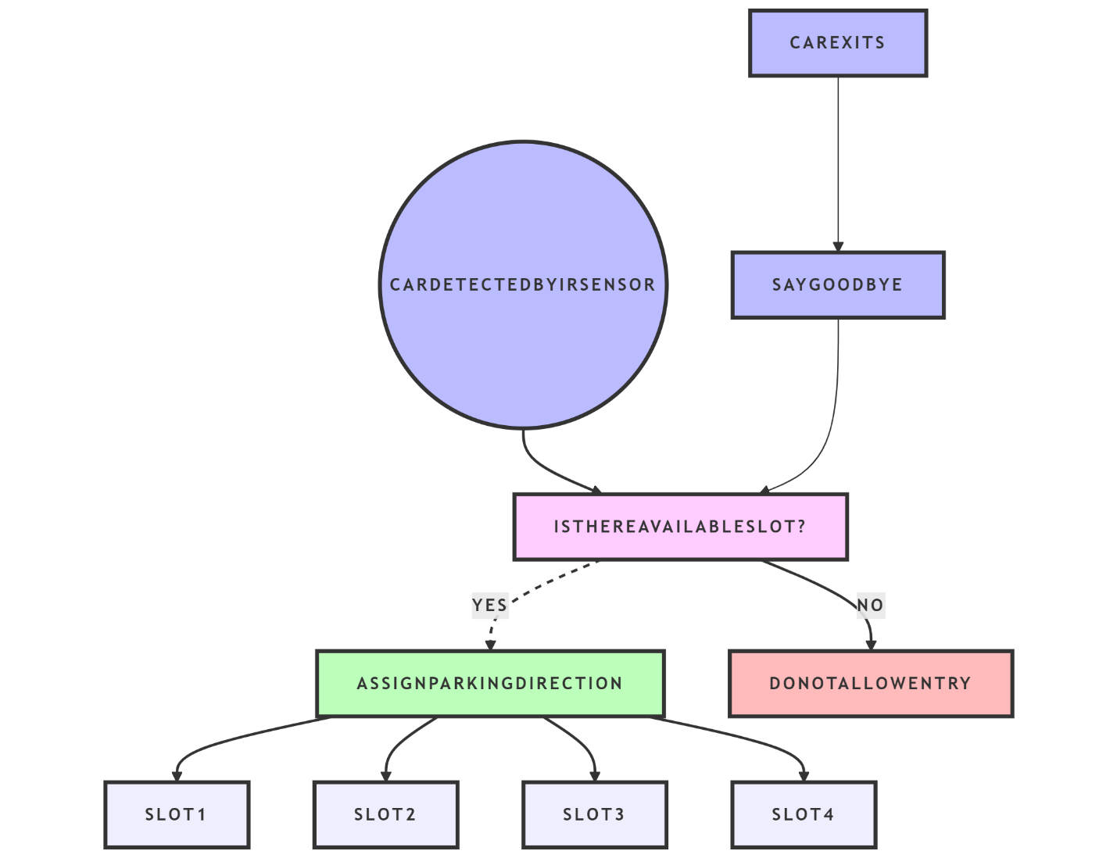

Fig.02: Circuit Diagram.

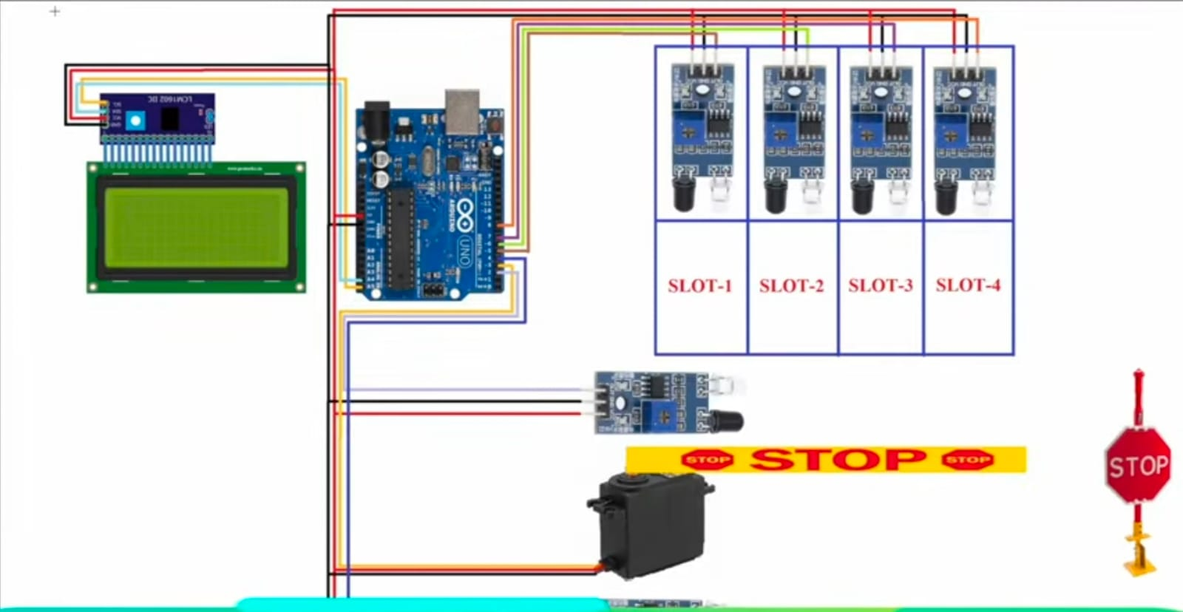

Working:
The Arduino-based parking system operates by using IR sensors to detect the presence or absence of vehicles in each parking slot. When a vehicle approaches, the system checks for available slots and displays the real-time status on an LCD screen. If a space is available, the servo motor-controlled gate opens automatically to allow entry. As vehicles enter or exit, the IR sensors update the slot status accordingly. The entire system is programmed using C++, ensuring smooth coordination between sensors, display, and motor for efficient parking management.
TABLE.01: System Integration and Operation.

COMPONENTS | DIAGRAM | IMPLEMENTATION
1.Arduino UNO | 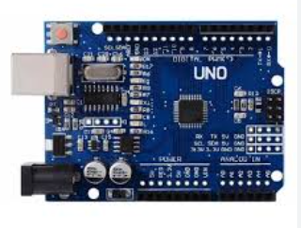 | 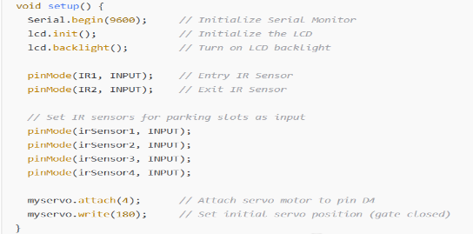
2.IR sensors | 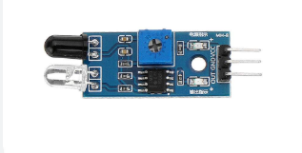 | 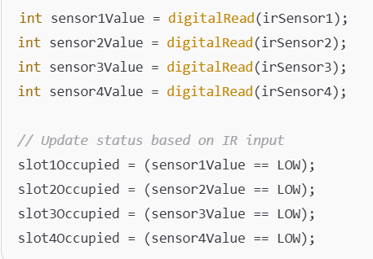
3.LCD &I2C module | 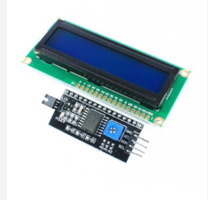 | 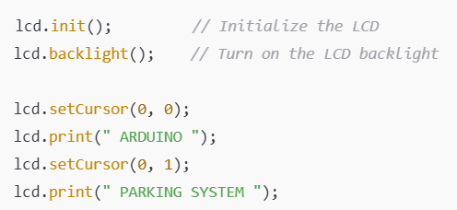
4.Servo motor | 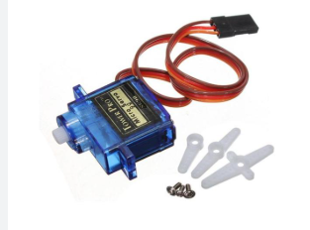 | 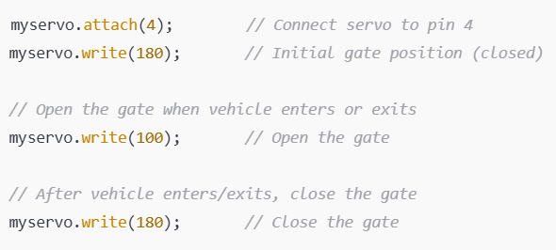
5.Jumper wires | 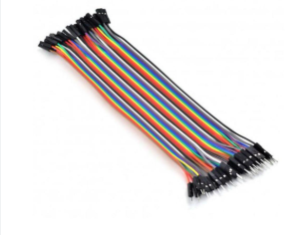 | Used for connecting various components on the breadboard.
6.Cardboard | 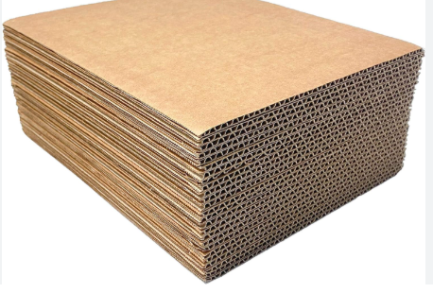 | Used as a base or structure for mounting the components and creating the parking slots.

Flowchart:

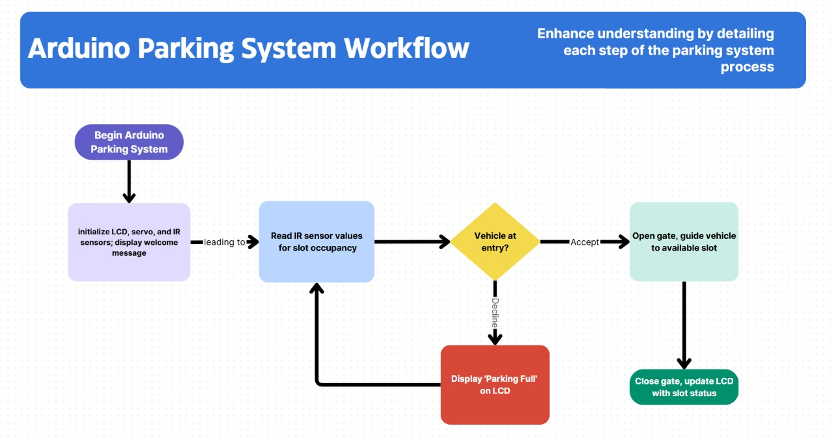
Software program:
#include <Wire.h>
#include <LiquidCrystal_I2C.h>
#include <Servo.h>

LiquidCrystal_I2C lcd(0x27, 16, 2);
Servo myservo;

int IR1 = 2; // Entry IR sensor
int IR2 = 3; // Exit IR sensor

int Slot = 4; // Total number of parking Slots

int flag1 = 0;
int flag2 = 0;

// Define the IR sensor pins for each slot (using digital pins) (SENSORS PROGRAM)
const int irSensor1 = 6; // Slot 1 (D6)
const int irSensor2 = 7; // Slot 2 (D7)
const int irSensor3 = 8; // Slot 3 (D8)
const int irSensor4 = 9; // Slot 4 (D9)

// Define the status of each parking slot
bool slot1Occupied = false;
bool slot2Occupied = false;
bool slot3Occupied = false;
bool slot4Occupied = false;

void setup() {
Serial.begin(9600);
lcd.init(); // Initialize the LCD
lcd.backlight(); // Open the backlight

pinMode(IR1, INPUT);
pinMode(IR2, INPUT);

// Initialize the IR sensor pins as inputs
pinMode(irSensor1, INPUT);
pinMode(irSensor2, INPUT);
pinMode(irSensor3, INPUT);
pinMode(irSensor4, INPUT);

myservo.attach(4);
myservo.write(180); // Initial position (closed)

lcd.setCursor(0, 0);
lcd.print(" ARDUINO ");
lcd.setCursor(0, 1);
lcd.print(" PARKING SYSTEM ");
delay(2000);
lcd.clear();
}

void loop() {
// Read the IR sensor values for each slot using digitalRead
int sensor1Value = digitalRead(irSensor1);
int sensor2Value = digitalRead(irSensor2);
int sensor3Value = digitalRead(irSensor3);
int sensor4Value = digitalRead(irSensor4);

// Determine if each slot is occupied
slot1Occupied = (sensor1Value == LOW);
slot2Occupied = (sensor2Value == LOW);
slot3Occupied = (sensor3Value == LOW);
slot4Occupied = (sensor4Value == LOW);

// Display the status of each slot (LCD PROGRAM)
lcd.setCursor(0, 0);
lcd.print("S1:");
lcd.print(slot1Occupied ? "Full”: "Empty");
lcd.print(" S2:");
lcd.print(slot2Occupied ? "Full”: "Empty");

lcd.setCursor(0, 1);
lcd.print("S3:");
lcd.print(slot3Occupied ? "Full”: "Empty");
lcd.print(" S4:");
lcd.print(slot4Occupied ? "Full”: "Empty");

// Entry and exit logic
if (digitalRead(IR1) == LOW && flag1 == 0) {
int freeSlots = 4 - (slot1Occupied + slot2Occupied + slot3Occupied + slot4Occupied);
if (freeSlots > 0) {
flag1 = 1;
myservo.write(100); // Open the gate by going up
Slot = Slot - 1;
lcd.clear();
lcd.setCursor(0, 0);
lcd.print(" WELCOME! ");
lcd.setCursor(0, 1);
if (freeSlots == 4) {
lcd.print("Go Straight ");
} else {
if (!slot4Occupied) {
lcd.print("Go Straight ");
} else if (!slot3Occupied) {
lcd.print("Turn Slight Left");
} else if (!slot2Occupied) {
lcd.print("Turn Left ");
} else if (!slot1Occupied) {
lcd.print("Turn Full Left ");
}
}
delay(3000);
lcd.clear();
} else {
lcd.setCursor(0, 0);
lcd.print(" SORRY :( ");
lcd.setCursor(0, 1);
lcd.print(" Parking Full ");
delay(3000);
lcd.clear();
}
}

if (digitalRead(IR2) == LOW && flag2 == 0) {
flag2 = 1;
myservo.write(100); // Open the gate by going up
lcd.clear();
lcd.setCursor(0, 0);
lcd.print(" GOODBYE! ");
delay(3000);
Slot = Slot + 1;
lcd.clear();
}

if ((flag1 == 1 || flag2 == 1)) {
myservo.write(180); // Close the gate by going straight
flag1 = 0;
flag2 = 0;
}

delay(100);
}

Conclusion:
The Arduino-powered automatic parking system effectively monitors and manages parking spaces by utilizing IR sensors and displaying real-time slot availability on an LCD screen. Through clear visual feedback, drivers are guided efficiently to available spots. A servo motor-operated gate facilitates smooth vehicle entry and exit. This project highlights the successful integration of C++ programming with hardware components, resulting in a practical, efficient, and user-friendly parking management solution.

